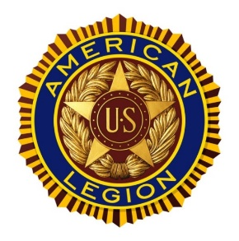
American Legion
Sylvester Post 335

INDOOR YARD SALE
FEB 10th 2024
DOORS OPEN 0800
THE SUMNER ROOM SYLVESTER PUBLIC LIBRARY
COME ON DOWN

